NAAN MUDHALVAN ASSIGNMENT

LOGO:

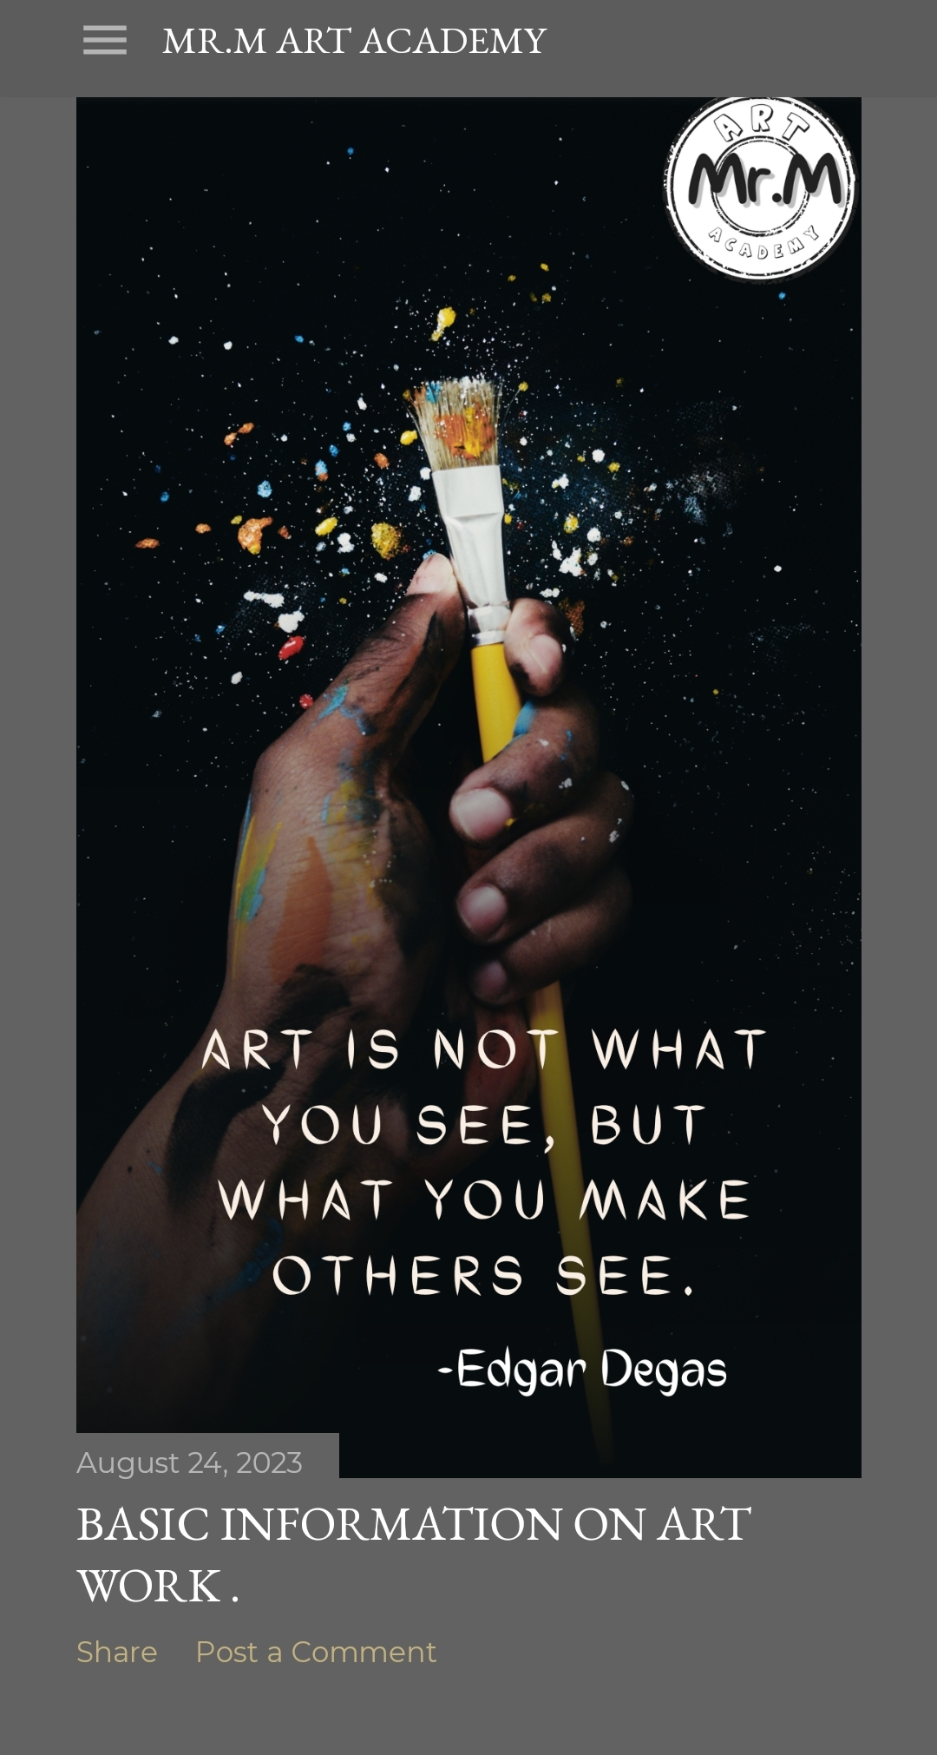

NEWSLETTER:

LINK: <https://mrmartacademy.blogspot.com/2023/08/email-newsletter-thanks-for-register.html>

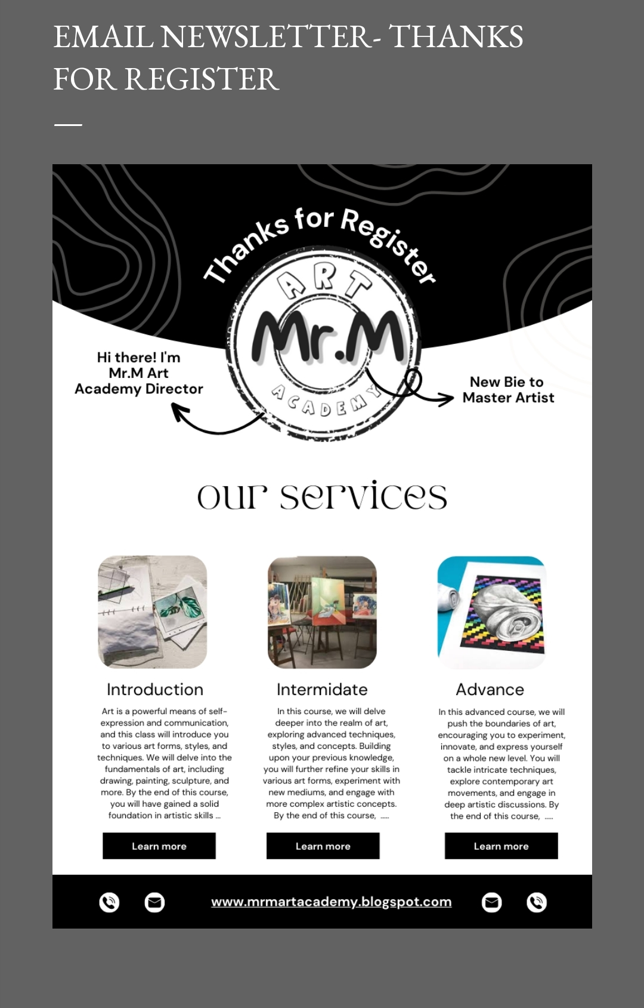

INFOGRAPHIC:

LINK: <https://mrmartacademy.blogspot.com/2023/09/how-to-be-successful-artist-inforgraphic.html>

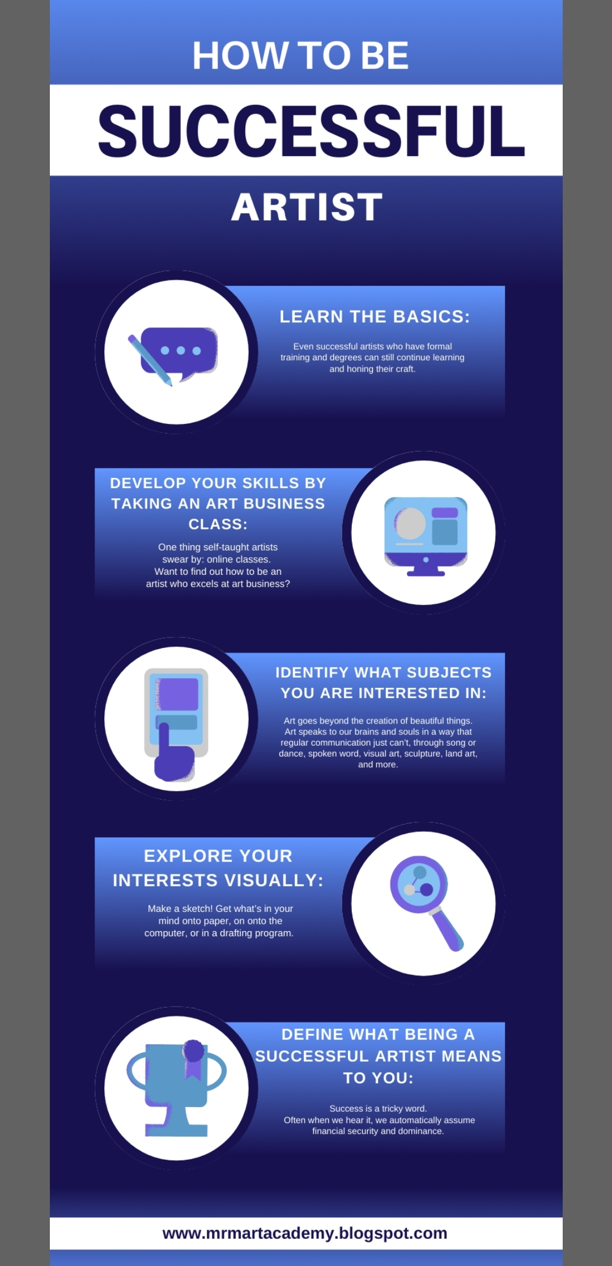

**Facebook business account:**

Link : <https://www.facebook.com/profile.php?id=61550634353001>

